Trevor Dowdell & TERRITORY GYMNASTICS ACADEMY

PHYSICAL ABILITY TESTING – INFORMATION PACK
Trevor Dowdell & TERRITORY GYMNASTICS ACADEMY

PHYSICAL ABILITY TESTING – INFORMATION PACK
Trevor Dowdell & TERRITORY GYMNASTICS ACADEMY
[Company name] [Company address]
PHYSICAL ABILITY TESTING – INFORMATION PACK
Evaluating the gymnast’s physical ability development - “That which gets measured gets done”

Physical Ability Tests (PAT) tests measure a gymnast’s current functional fitness and also measure on-going fitness improvements. Functional levels of physical ability are the key to good gymnastics performance. Clubs should systematically develop the physical ability of their competitive gymnasts. This is done by doing a base-line PA test, then implementing a conditioning program, and then re-testing at regular intervals to assess improvement towards the desired physical ability standards.
Encouraging coaches to practice functional fitness testing is a key objective of gymnastics training. The PA testing process also emphasizes the important motivational and reward aspects of improving fitness.

Physical Ability testing format
Test A comprises 10 tests and is designed for Level 3-5 gymnasts. Test B comprises 8 tests for Level 6-10 gymnasts. The test abilities (listed below with joint movement) are strength, flexibility, balance and some profile skill development. Tests are recorded in units of 1-20 or timed in seconds. These primary scores are then converted to a given score of 0-10 for strength, power test and balance tests; and 0-5 for flexibility tests.
Physical Ability Test A: for Level 3-5 gymnasts
Physical Ability | Prevailing Joint Action | Test Item | Repetition Range and  (Converted Score Range)
Strength | Hip Flexion | 1a. Straight Leg Lifts | 1 > 20 (1-10)
Strength | Shoulder Extension  and Hip flexion | 2a. Over-grip Chin Up | 1 > 20 (1-10)
Strength | Body Alignment &  Hip Flexion | 3a “L” lever - hold | Hold > 45sec (1-5)
Strength | Body Alignment &  Hip Flexion | 3b. Inverted hang-hold | Hold > 30sec (1-5)
Strength | Hip & Knee Extension | 4a. Single Leg Squats | 1 > 10 each leg (1-10)
Strength | Hip & Knee Extension | 4b. Rebound jumps | Jumps in 30s (1-5)
Strength & skill | Shoulder Flexion & hip extension | 5. Press to Handstand | 0 > 5 (1-10)
Balance | Balance & Alignment | 6. Handstand hold | Hold 1- 60sec (1-10)
Strength & skill | Dynamic Hip Flexion  Shoulder Extension | 7a. Glide Kips Series | Number performed in series (1-10)
Flexibility | Hip Flexion/Extension | 8a. Right Leg Splits  9a. Left Leg Splits | Flat splits > plus 20cm (0-5)  Flat splits > plus 20cm (0-5)
Power |  | 10. 20m sprint | Time in seconds (1-5)
 |  |  | TOTAL /90

Physical Ability Test B - for Level 6-10 gymnasts
Physical Ability | Prevailing Joint Action | Test Item | Repetition Range and  (Score Range)
Strength | Hip Flexion | 1b. Straight Leg Lifts from “L” | 1 > 20 (1-10)
Power | Shoulder Extension  and Hip flexion | 2b. 4m Rope climb – timed in seconds | 1-20sec (1-10)
Strength & skill | Shoulder Flexion & hip extension | 5. Press to Handstand | 0 > 5 (1-10)
Balance | Balance & Alignment | 6. Handstand Held | Hold 1- 60sec (1-10)
Strength & skill | Dynamic Hip Flexion  Shoulder Extension | 7b. Cast to handstand | Number performed (1-10)
Flexibility | Hip Flexion/Extension | 8b. Forward Leg raise  9b. Sideway Leg raise  9c.backward Leg raise | Height of toes R (0-5) L (0-5)  Height of toes R (0-5) L (0-5)  Height of toes R (0-5) L (0-5)
Power |  | 10. 20m sprint | Time in seconds (1-10)
 |  |  | TOTAL = / 80

Some of these tests can be used for lower level gymnasts. For example:
WAG Level 3: Tests 1a, 2a, 3a, 4, 5, 6, 8a, 9a, and 10 (for a total score out of 75)
WAG Level 4-5: Tests 1a, 2a, 3a, 3b, 4a, 4b, 5, 6, 7a, 8a, 9a, and 10 (for a total score out of 90)
Level 6-10: Tests 1b, 2b, 5, 6, 79, 8b, 9b, and 10 (for a total score out of 80)

An overall "gymnastic fitness" (%) score is given which can show the degree of overall improvement, or otherwise, from one test cycle to the next. For example, Test A and B are so designed that the gymnast should strive for an overall minimum "fitness" score goal of 30/100 for Level 3, 40/100 for Level 4, 50/100 for Level 5, 60/100 for Level 6, 70/100 for Level 7, and 80/100 for Level 9-10.

A test record sheet (for coach use) is attached. The test descriptions, photos of start and end positions, how to assess the tests and score conversion tables follow.
TESTS
Test 1A (Level 3-5) Straight Leg Lifts
Straight Leg Lifts - photo | Test Description | Test Scoring
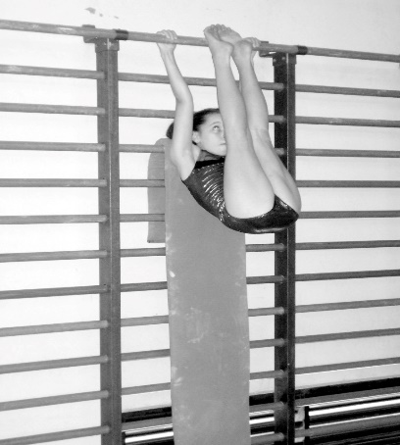 | Holding a wall (stall) bar, the gymnast begins in a straight hanging position with both hands in over grip - her body in a full hip & shoulder extension across padded rails.  The gymnast then performs a leg lift by bending at the hips to bring her feet to touch the bar. The legs must remain straight throughout the entire lift. The gymnast must touch the bar OR pass under the bar with her feet. | The number of completed leg lifts is divided in half to arrive at the converted score. For example:  20 leg lifts = converted score of 10  19 = 9.5 13 = 6.5 7 = 3.5  18 = 9 12 = 6 6 = 3  17 = 8.5 11 = 5.5 5 = 2.5  16 = 8 10 = 5 4 = 2  15 = 7.5 9 = 4.5 3 = 1.5  14 = 7 8 = 4 2 = 1  1 = 0.5
 | Test equipment - apparatus | Assessor instructions & Safety
 | Wall (stall) bars with bar padding extending under the gymnast’s body and feet.  Assessor stands to the side front of the gymnasts to observe the test performance. | The test starts when the gymnast begins her first leg lift.  Completed lifts are with straight legs  + pointed feet AND touch the top bar or pass under the top bar.  Assessors count aloud for each completed leg lift.  The test will conclude after 20 leg lifts are attempted OR after 5 unsuccessful attempts in a row.

Test 1B (Level 6-10 only) Straight Leg Lifts – from “L” hang
Straight Leg Lifts from “L” hang- photo | Test Description | Test Scoring
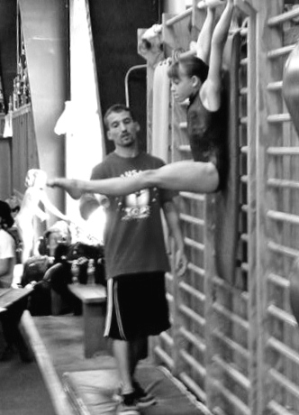 | The gymnast begins in a straight hanging position holding a wall (stall) bar with both hands in over grip - her body in a full hip & shoulder extension across padded rails.  The gymnast then performs her first leg lift to bring her feet to touch the bar. The legs must remain straight throughout the entire lift. The gymnast must either touch the bar or pass under the bar with her feet. She then lowers her legs to a horizontal (90 degree) position AND then performs the next leg lift by touching the bar. All subsequent leg lifts are to return to a horizontal “L” (90 degree) position.  If the gymnast’s legs fall below the horizontal position, the leg lift does not count. The test will conclude after 20 leg lifts are attempted or after 5 unsuccessful attempts in a row. | The number of completed leg lifts is divided in half to arrive at the converted score. For example:  20 leg lifts = converted score of 10  19 = 9.5 13 = 6.5 7 = 3.5  18 = 9 12 = 6 6 = 3  17 = 8.5 11 = 5.5 5 = 2.5  16 = 8 10 = 5 4 = 2  15 = 7.5 9 = 4.5 3 = 1.5  14 = 7 8 = 4 2 = 1  1 = 0.5
 |  | Assessor instructions - Safety
The test starts when the gymnast begins her first leg lift.
The assessor stands at the side of the gymnasts holding a padded stick (or their arm) at the horizontal position so the gymnast is aware of the horizontal “L” position (90 degree)
Assessors count aloud for each completed leg lift.

Test 2A (Level 3-5 only) Over-grip Chin Up
Chin Up - photo | Test Description | Test Scoring
Long Hang in top grip - Start of Chin-up test  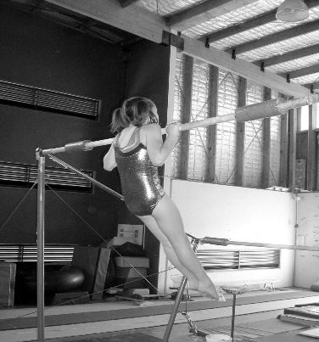  Chin-up to bar – then return to long hang | Gymnasts perform chin up in series up to a maximum of 20 attempts.  The gymnast hangs freely from a high uneven bar. The chin up must be done symmetrically, with straight legs, a slight hip extension and with the eyes rising to the bar.  If any of the above criteria are not met then that lift is not counted.  The test will end after 3 unsuccessful attempts at chin-up | A score of 0.5 point for each chin-up pullover performed.  20 chin = score 10  19 chin ups = score of 9.5  18 chin ups = score 9  16 chin ups = score 8  14 chin ups = score 7  12 chin ups = score 6  10 chin ups = score 5  8 chin ups = score 4  6 chin ups = score 3  4 chin ups = score 2  2 chin ups = score 1  A fall to hang negates that attempt, but the test continues. A fall from the bar ends the test.
 | Test equipment - apparatus | Assessor instructions - Safety
 | The test is performed on the high bar of a regulation set of uneven bars with 20cm of base matting under the low bar. The bar may be padded. | A coach may stand in to prevent the gymnast swinging but cannot aid the chin up  An additional 10 or 20 or 30 cm mat may be placed under the gymnast, but without feet contacting the mat.

Test 2B (Level 6-10 only) 4m Rope climb (arms only) – timed in seconds
4m Rope climb - photo | Test Description | Test Scoring
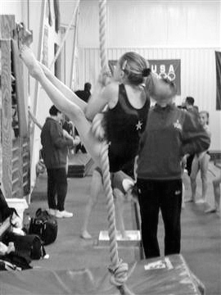 | The gymnast begins in “L” sit on a 30cm safety mat. She climbs as quickly as possible using arms only holding legs flexed at the hip in an “L” lever.  The gymnast’s legs must remain in a piked (legs together) position and held at or above horizontal throughout the test.  Timing begins on hand movement, and finishes as one hand passes the 4m mark.  While only the ascent is scored, the descent is in “L” lever to finish in sit on the safety mat. The test concludes if the gymnasts stops or grasps the rope with legs or feet. | Climb time in seconds & score  5 second = score of 10  5.5 sec = 9 10 sec =5  6 sec = 9 11 sec =4  7 sec = 8 12 sec= 3  8 sec = 7 15 sec =2  9 sec = 6 29 sec = 1  Form faults:  > Legs slightly bent - add 1 second  > Legs apart during - add 1 second  > Legs falling below horizontal, but  not below 45deg - add 1 second  > Legs falling below 45 degrees from  horizontal - add 3 seconds
 | Test equipment - apparatus | Assessor instructions Safety
 | 30+mm sisal climbing rope extending from floor to (at least) 5m in height. A stop watch records climb time in seconds. | A 30cm soft mat (at least 1.8x32m) must be centred under the climbing rope.

Test 3a (Level 4-5 only) Lever - holds
“L” Lever hold - photo | Test Description
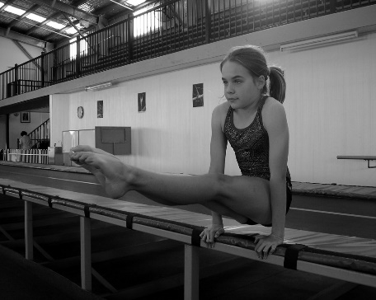 | The gymnast sits on a low ground beam with hand grasp next to hips, fingers pointing forward. In the “L” lever, the gymnast supports their body only on their hands and holds straight legs horizontally flexed at the hips.  The test begins when the gymnast lifts into an “L” lever hold.  The test concludes once the hold is lost or the legs drop below horizontal – in this case, the top edge of the beam.
Test Scoring | Test equipment - apparatus | Assessor instructions & Safety
45 secs hold = 5  42 sec = 4.5 25 sec = 2.5  39 sec = 4 20 sec = 2  33 sec = 3. 15 sec = 1.5  30 sec = 3 10 sec = 1  Less than 10sec =0.5 | A low ground beam with 10-20cm mats placed beside and behind the gymnast.  A stop watch is required to time the hold in seconds. | Instruct gymnast to breath naturally during the test. Ensure safety matting behind the gymnast in case of a backward fall – instruct gymnast to key hands in front of their body in a fall (avoid elbow injuries).
Test 3b (Level 4-5 only) Lever - holds
Inverted Hang - photo | Test Description
This test rates the isometric control of the important “dish shape” in gymnastics. The gymnast kicks to or lowers to an inverted hang on low bar. The gymnast must show
a shallow dish in the chest with extended hips and the bar in contact with the mid-thigh.
Time for holding the inverted hang is timed in seconds.

Test Scoring | Test equipment - apparatus | Assessor instructions & Safety
30 seconds hold = 5  29-27 sec = 4.5 17-15 sec = 2.5  26-24 sec = 4 14-12 sec = 2  23-21 sec = 3.5 11-9 sec = 1.5  20-18 sec = 3 8-6 sec = 1  Less than 5sec =0.5 | A low bar rails or metal bar.  A stop watch is required to time the hold in seconds. | Instruct gymnast to breath naturally during the test. Ensure safety matting behind the gymnast in case of a backward fall – instruct gymnast to key hands in front of their body in a fall (avoid elbow injuries).

Test 4 (Level 4-5 only) Single Leg Squats
Straight Leg Lifts - photo | Test Description | Test Scoring
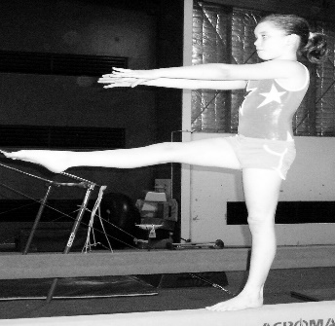  Single Leg Squat –start position  Single Leg Squat –full squat:  base foot remains flat  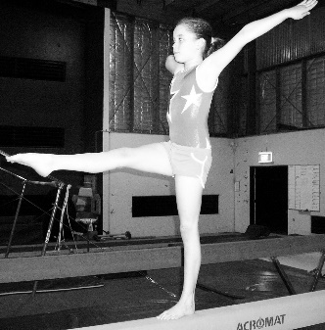  Single Leg Squat – finish position: arms pull sideways | The gymnast completes as many single leg squats as possible up to a maximum of 10 on each leg.  The gymnast stands on a ground level balance beam. The gymnast squats with control on the test leg with the free leg flexed forward at the hip.  A squat is counted when performed under control and in balance.  A test repetition is NOT scored If the gymnast loses balance OR the free leg touches the ground, but the test continues  While not a test condition, ideally the support knee should track forwards over the middle of the support foot. | The number of completed single leg squats is counted for each leg up to a maximum of 10 squats  The test will conclude after 10 squats are attempted OR after 3 unsuccessful attempts in a row  The raw score for each leg is recorded e.g. RL 8, LL 6 = 8 / 6  These scores are averaged for a converted score e.g. 8+6 = 14/2 = 7  Completed single leg squats R/L  10 + 10 = score of 10  10 + 9 = score of 9.5  9 + 9 = score of 9  9 + 8 = score of 8.5  8 + 8 = score of 8  2 = 1 = score of 1.5
 | Test equipment - apparatus | Assessor instructions & Safety
 | A low (ground level) balance beam.  10-20cm landing mats must cover the sides and back of balance bean. | Instruct gymnast to control the lower down into single leg squat.  Ensure safety matting behind the gymnast in case of a backward fall – instruct gymnast to key hands in front of their body in a fall (avoid elbow injuries).

Test 5 (Level 4-10) Press to Handstand
Press to handstand - photo | Test Description | Test Scoring
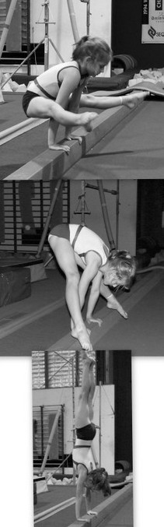 | The gymnast presses to handstand from a straddle lever on a firm surface or low (ground) beam. The hands cannot be farther apart than the width of the athlete’s shoulders. Fingers must face forward  The press must come to a completely straight handstand with the shoulders open.  Legs must come to a horizontal straddle L position at the beginning and end of each press.  The press will not count if the gymnast rests or push off her elbows in the straddle L position.  For any press to count, the gymnast must have a successful attempt on the up phase.  If the gymnast “walks” on her hands during any attempted press, the attempted press will not count. However, she may continue her attempts. The test is not over.  If the gymnast falls on her first press handstand attempt (or walks on her hands), she may have a second attempt. However, once the first press is completed, there will be no retest given. | One point is awarded for the press UP and another point for the press DOWN to lever.  5 continuous presses from half or straddle lever and return to lever = 10 points  4 continuous presses from half or straddle lever and return to lever = 8 points  3 continuous presses from half or straddle lever and return to lever = 6 points  2 continuous presses from half or straddle lever, to finish in lever = 4 points  1 continuous press to handstand from lever and return to lever = 2 points  1 continuous press from lever to handstand = 1 points  1 continuous press from feet to finish in handstand = 0.5 points
 |  | Assessor instruction-Safety
 |  | Ensure safety matting behind the gymnast in case of a backward fall while using a low balance beam – instruct gymnast to keep hands in front of their body in a fall (avoid elbow injuries).
Test equipment - apparatus
A low (ground level) balance beam or firm matted surface.
When using a balance beam,
10-20cm landing mats must cover the sides of balance bean.

Test 6 Handstand Held
Handstand hold- photo | Test Description | Test Scoring
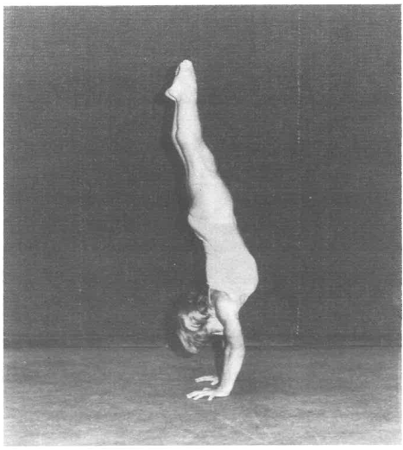 | The gymnast kicks up to a handstand on a padded non-spring floor.  Timing for this activity begins when the hands touch the floor.  Legs must be joined before a time of 10 seconds has elapsed.  Gymnasts must hold the handstand without any walking of the hands. | Two attempts can be made with the longest hold recorded.  60 second hold = score of 10  55-59 sec = 9 30-34 sec = 4  50-54sec = 8 25-29 sec = 3  45-49 sec= 7 20-24 sec = 2  40-44 sec = 6 10-19 sec = 1  35-39sec = 5 < 10s = 0.5
 | Test equipment - apparatus | Assessor instructions - Safety
 | Performed on a padded non-spring floor. A stop watch is needed to record the hold time. Parallettes are not to be used for this test. | Fingers must face forward

Test 7a (L4-6) Glide kip series
Glide kip series - photo | Test Description | Test Scoring
 | The gymnast performs as many continuous glide kips as possible up to a maximum of 10 in series. The gymnasts start from stand at floor level. A kip is counted when the gymnast reaches a straight arm support and casts to the next kip without an extra swing. After the first glide, glide swings may be piked or straddle piked.  Legs striking or pushing off the ground negate the performed kip, but the test continues. A fall (performance stops) ends the test.  The test ends after 3 unsuccessful attempts at kips. | Only the properly performed glide kip casts are counted. A properly performed kip cast has: arms & legs straight throughout. Bent arms in front support and/or in casting negate the performed kip (no points awarded) but the test continues. Glides must be clear of the mats (no floor strike) and with straight legs. If a gymnast brushes the floor with her feet in the glide she will receive 0.5 point for that glide kip.  10 glide kips in series = 10 points  9 glide kips in series = 9 and so on
Test equipment - apparatus |  | Assessor instructions -Safety
The test is performed on the low bar of a regulation set of uneven bars with 20cm of base matting under the low bar. The bar may be padded.
A single rail bar is not to be used.

Test 7b (Level 6-10 only) Cast to Handstand
Cast to handstand - photo | Test Description | Test Scoring
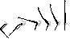 | The gymnast begins in a front support on the low bar on a set of regular competition uneven bars.  The test begins when the gymnast first casts and then returns to the bar in a front support. A maximum of 10 single casts can be performed.  The gymnast may have one fall however; she must immediately remount the bar (with no re-chalking) and continue her test. A fall is defined as: casting over the bar, falling forward while returning to the bar. After a fall, the test does not start over.  After 10 cast attempts, the test is over. | Only properly performed casts are counted. A properly performed cast handstand has: legs straight throughout the cast, arms straight throughout, and a straight (slightly extended hips) body position from the time their hips leave the bar to the time the hips return to the bar. Any arching or piking of the body on the way up or the way down negates that cast attempt. Cast must reach a straight handstand (within 10 degrees) to be counted. A cast to 45 degrees or above, but less than 10 degrees to handstand is awarded 0.5 points  If a gymnast completes a properly performed cast to handstand and then falls, she will receive 0.5 point.  10 casts to handstand = 10 points  9 cast to handstand = 9 and so on….
Test equipment - apparatus |  | Assessor instructions - Safety
The test is performed on the low bar of a regulation set of uneven bars with at least 40 cm of matting (20 cm base + 20 cm landing mat) but not more 50 cm of matting (20 cm base + 30 cm soft mat) placed under the low bar. A single rail bar is not to be used. |  | The coach can stand next to the low bar for safety purposes, but cannot spot the gymnast. Gymnasts SHOULD be able to safely exit from handstand on bars.

Test 8a and 9a (Level 3-5 only) Forward Splits – right leg & left leg
Forward splits – photo | Test Description | Test Scoring
Score 3 = flat splits, parallel legs, square shoulders, vertical torso  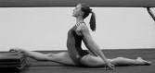  Score 4 = 20cm over split front leg  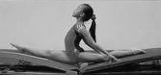  Score 5 = 20cm over split both legs | This test is conducted in two steps. Firstly on a lined mat area. The gymnast slides into a split position with front leg on one side of a velcro line and the back leg on opposite side. A score is given based on flat splits and other postures.  If the gymnast scores 3, she may attempt to over split using the spring boards. The front leg may be raised (attempt score 4) OR both legs raised with upper torso directly over where two spring boards join (attempt score 5). Gymnast’s hands cannot take bodyweight but may touch the floor or the spring boards | Forward split posture (each leg):  Not yet flat splits = score 0  Flat splits, legs straight = score 1  Flat splits, legs straight & parallel = 2  Flat splits legs straight & parallel with square shoulders = score 3  Flat over splits front leg heel raised on 20cm spring board with legs straight & parallel, square shoulders and vertical torso = score 4  Flat over splits on joined springboards WITH legs straight & parallel, square shoulders and vertical torso = score 5
 | Test equipment - apparatus | Assessor instructions - Safety
 | For flat splits - 2m long velcro strip placed lengthways on carpeted mat.  For over split -Two regulation height spring boards set end to end. A 2m long velcro line is placed centrally along the joined springboards. | Legs parallel include front knee facing upward and back knee facing down. Flat splits means the gymnast’s back leg thigh & front leg hamstring area rests on the floor for at least 5 sec.  Pushing down on legs is not permitted
Test 8b and 9b (Level 6-10 only) Forward Leg Raises and Sideways Leg Raises
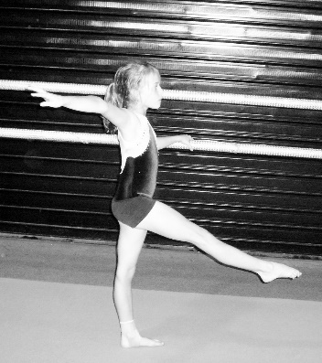  Score 1 = at knee | 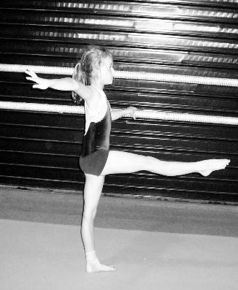  Score 2 = at hip | 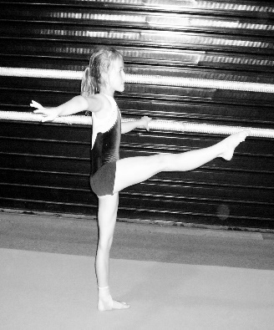  Score 3 = at mid-chest (sternum) | 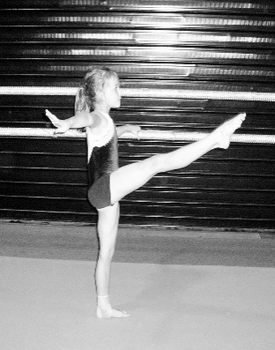  Score 4 = at shoulder
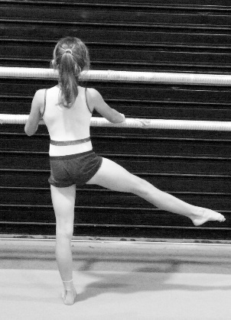  Score 1 = at knee | 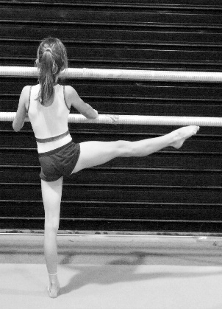  Score 2 = at hip | 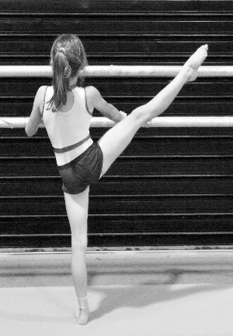  Score 3 = at mid-chest (sternum) | 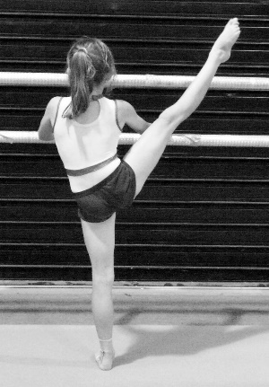  Score 4 = at shoulder
Test Description and scoring
These tests demonstrate the active flexibility of the hips i.e., “splits” in movements.  The gymnast stands beside a balance beam or barre’. The gymnast extends each leg (both forward then both sideways) as high as possible and holds for at least 3 seconds. The height of the toes is observed and a score is given. Legs must be straight, turned out from the hips and the body held upright and square.  Each leg (R&L) receive a score out of 5 points. The total points score is therefore 20. |  | Raised leg toe position Score  Top of head 5  Shoulder tip 4  Base of sternum 3  Hip (top of iliac crest) 2  Top Knee cap 1  Below knee 0
 |  | Test equipment - apparatus
 |  | Ballet barre’ at (at least) two heights. A balance beam or other firm hand hold to be used. Floor surface must be firm.

Test 10 20m Sprint
20 m Sprint - photo | Test Description | Test Scoring
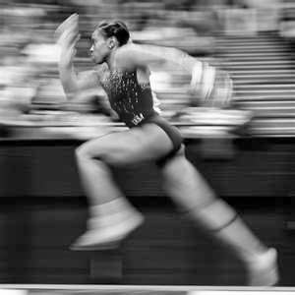 | The 20 metre sprint is performed on the non-slip vault runway.  The gymnast begins behind the start line with one or both feet touching the far edge of the start line.  Gymnasts begin their sprint when ready. There is NO “Ready-Set-go” command.  The assessor is positioned at the finish line of the 20 metre.  Gymnastics shoes cannot be worn during the test. | The assessor starts the stopwatch when the gymnast’s first leg lifts forward (moves past the starting line). The watch is stopped when any part of the gymnast’s torso crosses the finish line.  Time is recorded to the hundredth of a second. Two attempts should be permitted with the best time counting as the final result.  2.99 sec or better = 10 points  3.10 sec = 9 3.20 sec = 8  3.30 sec = 7 3.40 sec = 6  3.50 sec = 5 3.60 sec = 4  3.70 sec = 3 3.80 sec = 2  3.90 sec = 1 4.00 sec = 0
Test equipment - apparatus |  | Assessor instructions - Safety
30 metres (or more) of a clear area is to be used for the 20 metre sprint.  The test is usually conducted on a vault runway. A spring floor area is NOT to be used. A stopwatch is needed to record the time. |  | A clear area of at least 10 metres long is needed for the gymnast to slow down at the end of the 20 metre sprint. Any walls at the end or near the 30metre mark must be padded.

WG Physical Ability Test – scoring tables
Test 1A and 1B – Leg lifts
Leg Lifts | 2 | 4 | 6 | 8 | 10 | 12 | 14 | 16 | 18 | 20
Score | 1 | 2 | 3 | 4 | 5 | 6 | 7 | 8 | 9 | 10
Test 2A – Chin Ups
Chin Ups | 2 | 4 | 6 | 8 | 10 | 12 | 14 | 16 | 18 | 20
Score | 1 | 2 | 3 | 4 | 5 | 6 | 7 | 8 | 9 | 10
Test 2B – Rope Climb
Time sec
Score | 1 | 2 | 3 | 4 | 5 | 6 | 7 | 8 | 9 | 10
Test 3a - “L” Lever hold
Time | < 10 | 10 | 15 | 20 | 25 | 30 | 33 | 39 | 42 | 45
Score | 0.5 | 1 | 1.5 | 2 | 2.5 | 3 | 3.5 | 4 | 4.5 | 5
Test 3b - Inverted Hang
Time held (sec) | 30 | 29-27 | 26-24 | 23-21 | 20-18 | 17-15 | 14-12 | 11-9 | 8-6 | 5-3 | 2-1
Score | 5 | 4.5 | 4 | 3.5 | 3 | 2.5 | 2 | 1.5 | 1 | 0.5 | 0
Test 4a - Single Leg Squats
Squats | 1 | 2 | 3 | 4 | 5 | 6 | 7 | 8 | 9 | 10
Score | 1 | 2 | 3 | 4 | 5 | 6 | 7 | 8 | 9 | 10
Test 4b- Rebound Jumps
Squats | 1 | 2 | 3 | 4 | 5 | 6 | 7 | 8 | 9 | 10
Score | 1 | 2 | 3 | 4 | 5 | 6 | 7 | 8 | 9 | 10
Test 5 - Press Handstand: One point for the press UP and another point for the press DOWN to lever.
5 continuous presses from half or straddle lever and return to lever = 10 points  4 continuous presses from half or straddle lever and return to lever = 8 points  3 continuous presses from half or straddle lever and return to lever = 6 points | 2 continuous presses from half or straddle lever, to finish in lever= 4 points  1 continuous press to handstand from lever and return to lever = 2 points  1 continuous press from lever to handstand = 1 points  1 continuous press from feet to finish in handstand = 0.5points
Test 6 - Hold Handstand
Time | <10s | 10-19 | 20-24 | 25-29 | 30-34 | 35-39 | 40-44 | 45-49 | 50-54 | 55-59 | 60
Score | 0.5 | 1 | 2 | 3 | 4 | 5 | 6 | 7 | 8 | 9 | 10
Test 7A - Glide Kips
A properly performed kip cast has: legs straight throughout. Bent arms in front support and/or in casting negate the performed kip (no points awarded) but the test continues.
Kips | 1 | 2 | 3 | 4 | 5 | 6 | 7 | 8 | 9 | 10
Score | 1 | 2 | 3 | 4 | 5 | 6 | 7 | 8 | 9 | 10
Test 7B – Cast Handstand
Cast Hstd | 1 | 2 | 3 | 4 | 5 | 6 | 7 | 8 | 9 | 10
Score | 1 | 2 | 3 | 4 | 5 | 6 | 7 | 8 | 9 | 10
Test 8a and 9a – Front Splits R + L and Side splits
Front Split | Flat legs straight | Flat splits, legs straight & parallel | Flat split- legs straight parallel & square should | AND Over splits Front leg raised 20cm -springboard | AND Over splits both leg raised 20cm-box
Score | 1 | 2 | 3 | 4 | 5
Side Split | 10cm above floor | Flat splits | Flat split | Flat split, shld square, torso vertical arms up | Over splits - both leg raised 10cm
Test 8b and 9b – Forward and sideways Leg Lifts R + L
Forward Leg Lift | Tow at top of knee cap | Toe at hip (iliac crest) | Toe at base sternum | Toe at shoulder tip | Toe at top of head
Score | 1 | 2 | 3 | 4 | 5
Sideway  Leg Lift | Tow at top of knee cap | Toe at hip (top of iliac crest) | Toe at base of sternum | Toe at shoulder tip | Toe at top of head
Test 10 – 20m sprint
Time sec | 3.9 | 3.8 | 3.7 | 3.6 | 3.5 | 3.4 | 3.3 | 3.2 | 3.1 | < 3.0
Score | 0.5 | 1 | 1.5 | 2 | 2.5 | 3 | 3.5 | 4 | 4.5 | 5

Physical Ability Test record : Group……………..…….….Date of test…………….………Venue………..…………………...…

First name,  SURNAME  Age – Level  Club | Test  1a - 1 b  Leg  Lifs  n/10 | Test  2a – 2 b  Chin Up  Rope  /10 | Test 3a  “L” lever hold  sec/5 | Test 3b  Inverted hang  sec/5 | Test 4a  Single Squats  R-L / 10 | Test 4b  Rebound  Jumps  /10 | Test 5  Press  Hstd  /10 | Test 6  H/std  Hold  sec/10 | Test 7A  Glide Kips  n / 10 | Test 7b Cast Hstd  n/ 10 | Test 8-9a  Splits  R/L  /5/5 | Test 8-9b  Leg raise  Forward  R – L  /5/5 | Test 8-9b  Leg raise  Sideways  R – L  /5/5 | Test 10  Sprint  20m  sec/5 | Total  /100 %
Average
SD

